Gary Zhou, Alexander Park

Nov 20th, 2019

CS 170 project phase 1 design doc

**Problem:**

The Driving TAs home problems, we are tasked to find a shortest bus route such that the total energy spent by the students and drivers is minimized. More generally, we are given a graph and a list of home as inputs, and we want to find a route such that the total energy it takes the car to drive the route plus the total energy it takes for TAs to walk home is minimized.

**Approach 1:**

Naïve: Make every TA walk home.

Analysis: This is a very bad approach because we don’t utilize the car, which expends 2/3 the amount of energy as a TA when traveling the same distance.

**Approach 2:**

Greedy: Find a path that visits all the TA’s homes using the nearest neighbor greedy algorithm. This algorithm visits the nearest unvisited vertex until all vertices are covered.

Analysis: This approach is better than the naïve approach as we fully utilize the car and the students don’t have to walk at all. However, this doesn’t yield the optimal solution because this is a greedy algorithm, and we are trapped in a local optimum and cannot improve further.

**Approach 3:**

Iterative Improvement (local search): The iterative improvement algorithm we are using is the 3 opt algorithm. Given a valid tour, what this algorithm does is remove three random edges in the tour and connects the end points in different ways to see if we can lower total distance of the tour. We repeatedly do this until we can no longer lower the distance. The following picture gives an idea of what the algorithm is doing.

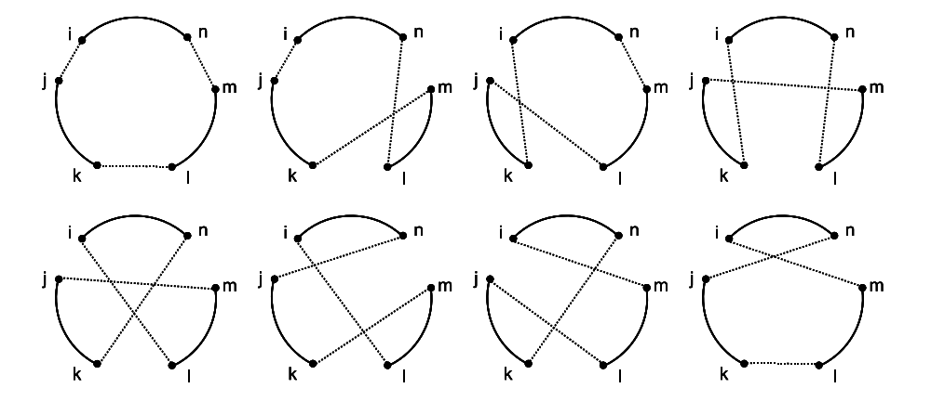

Analysis: We first generate a tour using the greedy algorithm. Then we do local search to improve on the greedy tour. This algorithm can effectively reduce the distance of the tour while keeping the tour valid.

**Approach 4:**

Ant colony optimization: Use ant colony optimization algorithms to compute shortest tours in a graph.

Analysis: This is an advanced algorithm that uses probabilistic ants to good paths in a graph. This algorithm can be used to solve the TSP problem that we have. We will use a library package instead of implementing the algorithm ourselves. After some tries, this algorithm finds tours with costs close to the tour found using the iterative improvement algorithm.

**Approach 5:**

Greedy bus stop assignment + iterative improvement: Start with a tour only containing the starting node. Iteratively add a new node (bus stop) that lowers the total energy spent by the most. We do this until we can no longer lower the total energy.

Analysis: In the previous algorithms, we don’t make students walk. We can potentially reduce the total energy if we make the students walk a little bit. The bus stop allocation is very similar to the set cover problem discussed in class. The should be solutions better than this greedy approach to bus stop allocation.